

College of Engineering and Computer Science

***ECS 511 – Sustainable Manufacturing***

***Assignment – 1***

***Applying Methods and Tools for Developing Sustainable Products***

***Submitted by:***

***Rishi Siddanth Yaga***

***627161225***

[***riyaga@syr.edu***](mailto:riyaga@syr.edu)

***Table of Contents***

**Summary Statement………………………………………………… 03**

**Context of the Product and Need for Sustainability..........................04**

**Breakdown of Chosen Product............................................................07**

**Photos of Disassembly.................................................................07**

**Bill of Materials............................................................................16**

**Current end-of-life for Product...........................................................17**

**Geographic Location............................................................................20**

**Strategies for Change...........................................................................23**

**Conclusion: Recommendations...........................................................27**

**Bibliography..........................................................................................29**

***Summary Statement***

The primary objective of this report is to meticulously evaluate the sustainability aspects of a consumer product and explore avenues for enhancing its environmental friendliness where necessary. The focus of our analysis is the digital LED table lamp manufactured by the renowned Mainstays brand and retailed through Walmart. In an era where responsible resource utilization to mitigate depletion and long-term environmental harm is paramount, prioritizing sustainability across every facet of a product's lifecycle is imperative for the modern production of consumer goods.

The humble table lamp, a staple in households since its mass production began in the late 19th century, may face stiff competition from smartphones as alternative light sources. However, it still commands a significant demand, underscoring its enduring relevance in contemporary living spaces.

Throughout the course of this report, we will address a series of pivotal questions related to the LED table lamp. This includes examining its broader contextual relevance, articulating the imperative for sustainability in its production, dissecting its component breakdown, assessing disassembly considerations, scrutinizing the materials employed in its construction, identifying opportunities for sustainable enhancements, evaluating end-of-life management strategies, and ultimately outlining a comprehensive roadmap for bolstering sustainability.

Sustainability, in its true essence, must be seamlessly woven into every phase of a product's lifecycle to safeguard the Earth's finite resources and minimize environmental impacts. By closely scrutinizing the widely available LED table lamp sold by Walmart, this report not only underscores the significance of sustainability in consumer product manufacturing but also provides tangible insights and actionable recommendations for a more sustainable future.

***Context of the Product and Need for Sustainability***

A LED lamp, short for Light Emitting Diode lamp, is a revolutionary lighting solution that has transformed the way we illuminate our homes and spaces. These lamps use semiconductor technology to produce light efficiently, making them incredibly energy-efficient and long-lasting compared to traditional incandescent or fluorescent bulbs. LED lamps are known for their bright, cool, and consistent light output, making them ideal for various applications, from residential lighting to commercial and industrial settings. Not only do LED lamps consume less electricity, reducing energy bills, but they also have a significantly longer lifespan, reducing the need for frequent replacements. Furthermore, they come in a wide range of styles and color temperatures, allowing users to customize their lighting to suit their preferences and needs. LED lamps have not only revolutionized the lighting industry but have also played a crucial role in promoting sustainability and energy conservation.

The product analyzed in this report is a LED desk lamp by ‘Mainstays’. The Mainstays table lamp uses less energy and is cooler to the touch than CFL or incandescent bulbs. With 3.5-watt high-power LEDs boasting 240 lumens and no need to replace bulbs, it is a definite energy saver. The Mainstays LED Desk Lamp contains no mercury and have 3 different light modes and 3 Brightness Level. The following are the features of the table lamp:

* Bulb: 3.5-watt LED
* Movement Type: Electric
* Power Source: Power Cable & USB Charging
* Materials: Plastic & Aluminum
* Dimensions: 4.70 x 9.30 x 14.30 Inches
* Key Features: 3-way Dimmable Lights, USB Charging

Sustainability is a central aspect of LED lamps. These lighting devices contribute to sustainability in several ways:

* Energy Efficiency: LED lamps are highly energy-efficient, converting a larger percentage of electricity into light compared to traditional incandescent or fluorescent bulbs. This reduces overall energy consumption, lowering electricity bills and decreasing the demand for fossil fuels, which in turn helps combat climate change.
* Longevity: LED lamps have an exceptionally long lifespan, often lasting tens of thousands of hours before needing replacement. This longevity reduces the amount of waste generated from discarded bulbs and decreases the need for manufacturing, transportation, and disposal associated with frequently replacing traditional bulbs.
* Reduced E-Waste: Because LED lamps last longer, they contribute to the reduction of electronic waste (e-waste) generated by the disposal of old and burnt-out bulbs. This is a significant sustainability benefit, as e-waste disposal and recycling are environmental concerns.
* Lower Carbon Footprint: LED lamps have a lower carbon footprint due to their reduced energy consumption and longer lifespan. They help reduce greenhouse gas emissions associated with electricity generation, contributing to a more sustainable and environmentally friendly lighting solution.
* Mercury-Free: Unlike fluorescent lamps, which contain small amounts of mercury, LED lamps are mercury-free. This eliminates the environmental hazards associated with mercury exposure and the need for special disposal procedures.
* Dimmability and Light Control: Many LED lamps are dimmable and offer advanced light control options, allowing users to tailor their lighting to specific needs. This not only enhances user comfort but also reduces energy consumption when full brightness is not required.

In summary, LED lamps play a significant role in sustainability by reducing energy consumption, extending product lifespans, minimizing waste generation, and offering cleaner and more efficient lighting solutions. These attributes make LED lamps an essential component of efforts to create a more environmentally responsible and sustainable lighting industry.

Fig. Sustainability Flowchart

***Breakdown of chosen product***

In this section, the product will be broken down into its individual components, followed by a bill of materials.

*Photos of Disassembly:*

Disassembly of a product is the systematic process of taking apart a manufactured item, to understand its inner workings, repair any faults, recycle components, or simply recycle the entire product. It involves carefully removing each component or part, often in reverse order of assembly, while preserving their integrity for potential reuse. Disassembly is a crucial step in product lifecycle management, contributing to sustainability efforts by reducing waste and extending the useful life of components and materials. It also plays a significant role in product design and engineering, enabling improvements in repairability, upgradability, and end-of-life considerations.



*Fig.1 – Base of the LED lamp.*

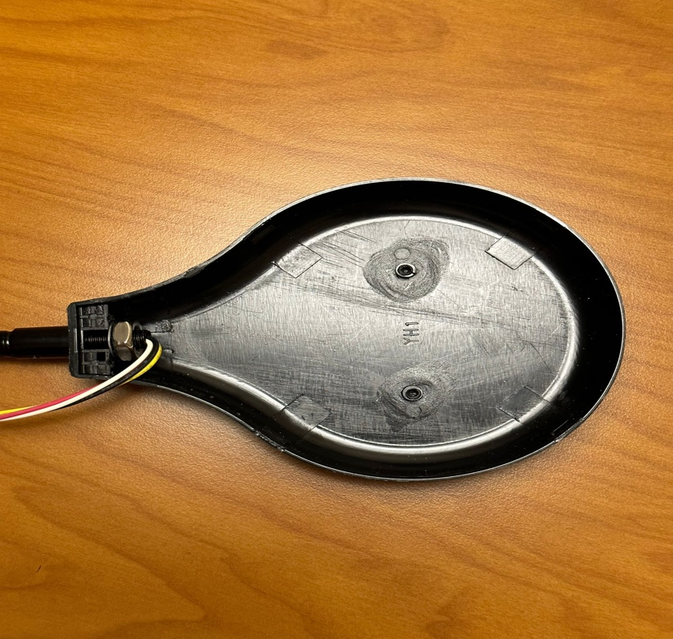

*Fig.2 – LED Light Holder*

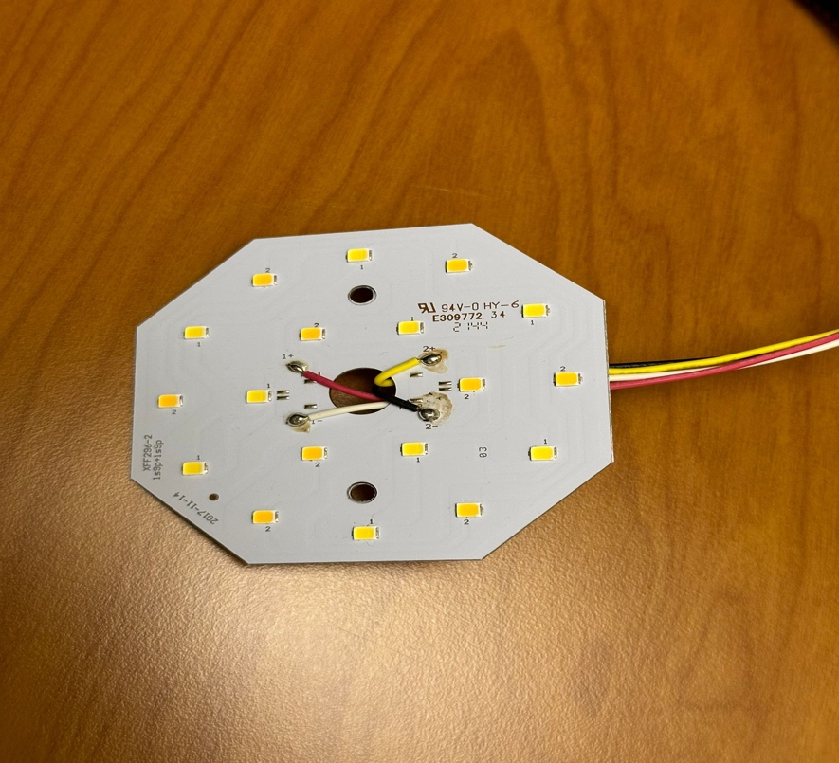

*Fig.3 – LED Light*

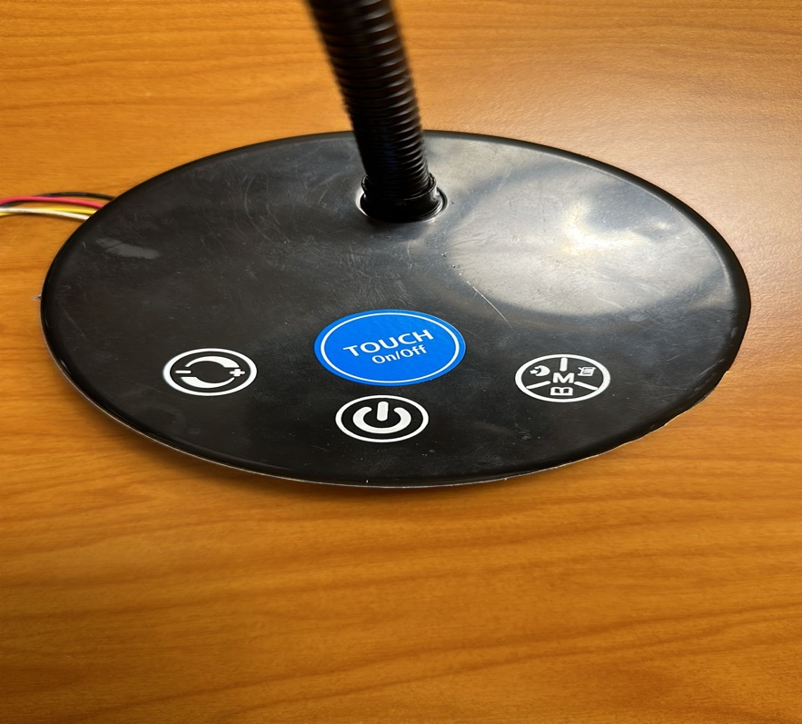

*Fig.4 – Lamp Base (Top View)*

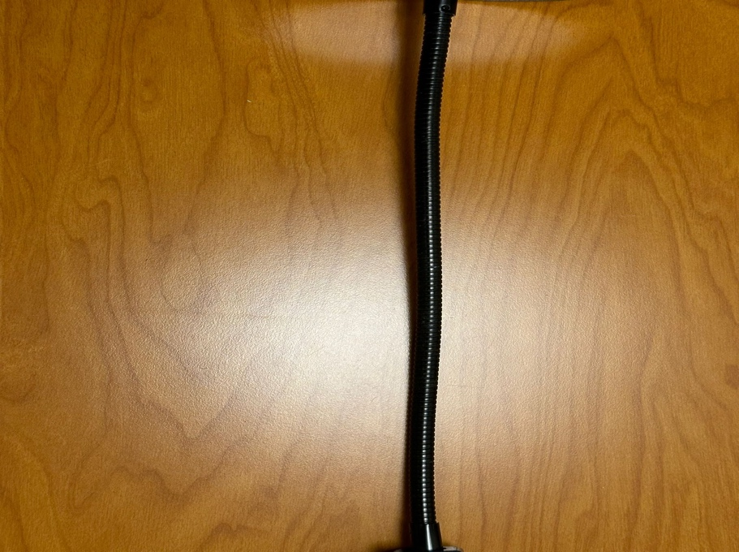

*Fig.5 – Aluminum Rod Connecting base and lamp head*

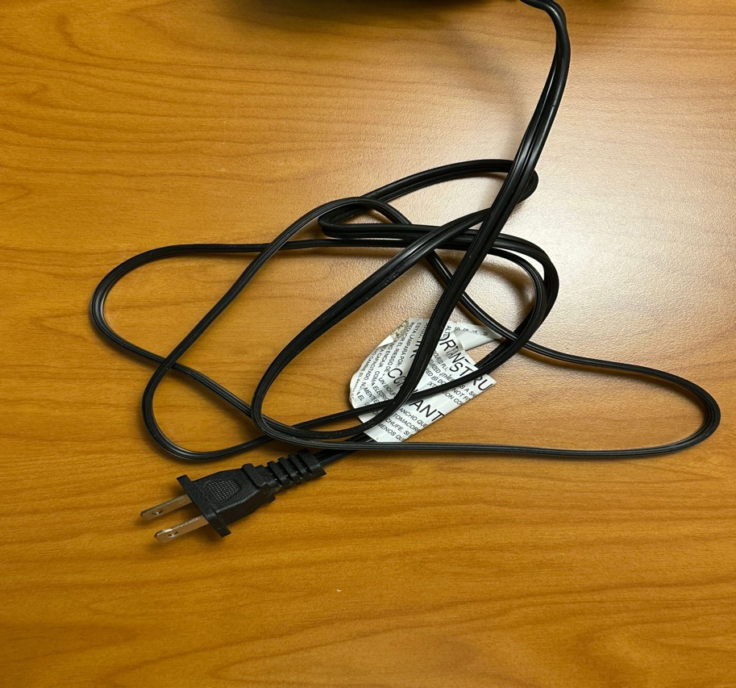

*Fig,6 – Power cord*

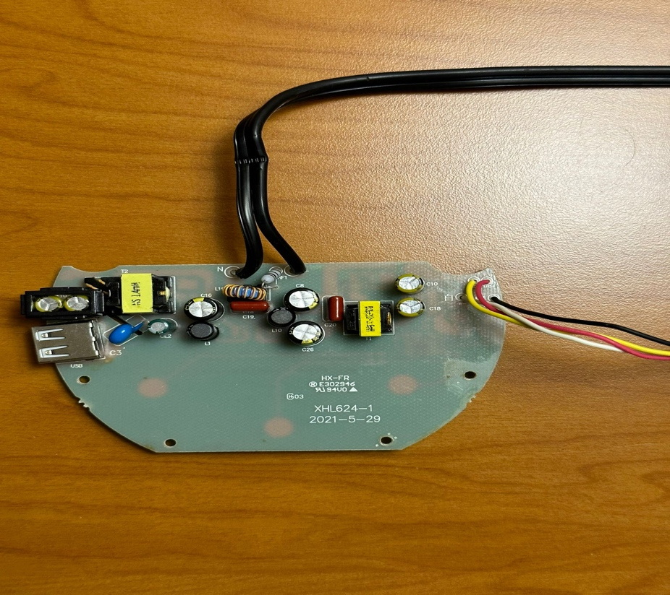

*Fig.7 – Electric Circuit Board*



*Fig.8 – Screws to connect Circuit board to base*

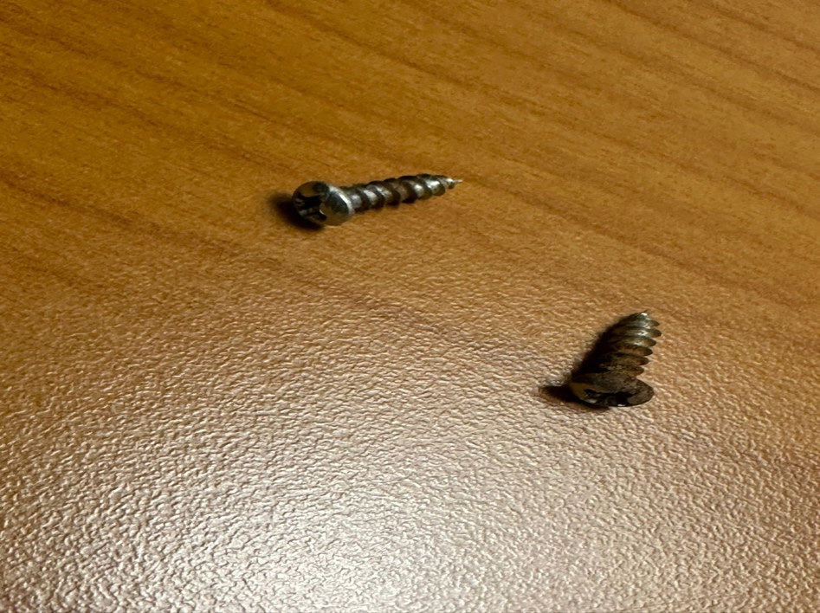

*Fig.9 – Screws to connect Metal Weight to base*



*Fig.10 – Metal Weight*

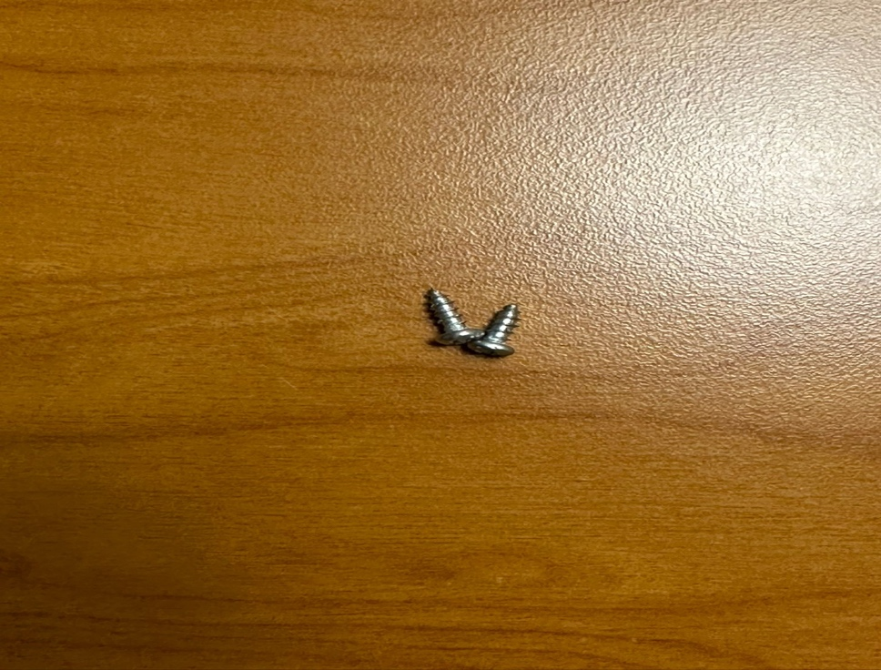

*Fig. 11 – Screws to connect LED Light to Light Holder*



*Fig.12 – LED Light holder base cover.*

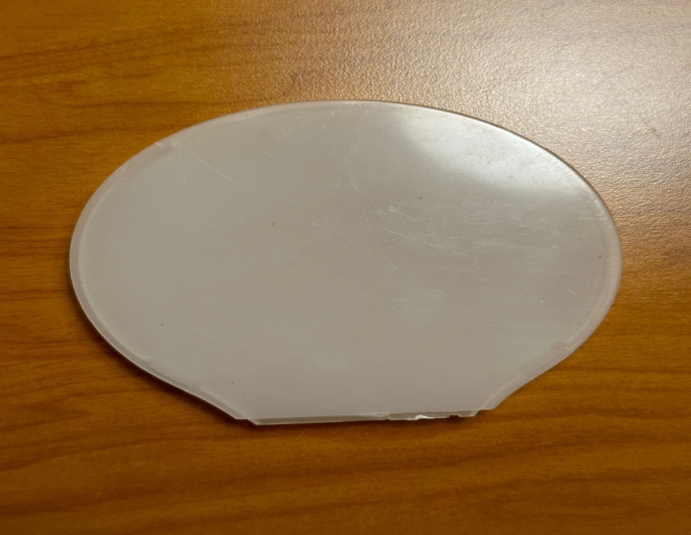

*Fig. 13 – LED Light Cover*



*Fig. 14 – Screws to connect base cover to base of lamp*



*Fig.15 – Base cover*



*Fig.16 – Screws to connect wire cover to Base of lamp*



*Fig.17 – Wire Cover*

***Bill of Materials:***

A Bill of Materials (BOM) is a comprehensive list or document that itemizes all the materials, components, parts, and sub-assemblies needed to manufacture a product, build a structure, or complete a project. It provides a detailed breakdown of the quantities, descriptions, and sometimes additional information such as part numbers, suppliers, and costs for each item on the list. BOMs are commonly used in manufacturing, construction, engineering, and various industries to ensure accurate planning, procurement, assembly, and tracking of materials throughout the production or project lifecycle.

|  |  |  |  |  |
| --- | --- | --- | --- | --- |
| *S.NO* | *PART NUMBER* | *PART NAME* | *PART QUANTITY* | *PART MATERIAL* |
| 1 | LED-001 | Lamp Base | 1 | Plastic |
| 2 | LED-002 | LED Light Holder | 1 | Plastic |
| 3 | LED-003 | LED Light | 1 | Electric Light source |
| 4 | LED-004 | Aluminum Rod | 1 | Metal |
| 5 | LED-005 | Power Cord | 1 | PVC, Copper |
| 6 | LED-006 | Screws | 13 | Metal |
| 7 | LED-007 | Wire Cover | 1 | Plastic |
| 8 | LED-008 | Base Cover | 1 | Plastic |
| 9 | LED-009 | Metal Weight | 1 | Metal |
| 10 | LED-010 | Electric Circuit Board | 1 | Electric Laminate Board |
| 11 | LED-011 | Light holder Base Cover | 1 | Plastic |
| 12 | LED-012 | Light Cover | 1 | Plastic |

***Current end-of-life for Product***

The company Mainstays does not provide explicit information regarding the lifecycle of its LED table lamp. However, upon analyzing the lamp's material composition, it becomes evident that a significant portion of the product is constructed from plastic known for its recyclability. Whether the lamp ultimately becomes environmentally friendly largely depends on whether the user chooses to recycle it or simply discards it.

The product life of a LED table lamp is influenced by a multitude of factors, each playing a crucial role in determining how long the lamp will continue to provide illumination and aesthetic appeal. Let's delve into these factors and explore how they collectively shape the lifespan of this table lamp.

* *Quality of Materials and Construction:* The foundation of any durable table lamp lies in the quality of its materials and construction. Lamps made from high-quality materials such as metal, glass, or robust plastics tend to withstand the test of time. These materials not only enhance the lamp's aesthetics but also contribute to its longevity. When combined with meticulous construction that ensures strong joints and secure electrical connections, the lamp becomes less prone to developing issues over time.
* *Type of Bulbs Used:* The choice of light bulbs is another pivotal determinant of a lamp's product life. Modern LED bulbs have become the gold standard for longevity, often outlasting traditional incandescent or CFL bulbs by several years. Regularly replacing bulbs as they burn out, irrespective of the bulb type, can significantly extend the overall life of the lamp. This practice ensures that the lamp remains functional and continues to provide quality lighting.
* *Usage Patterns:* How frequently and for how long the lamp is used has a substantial impact on its lifespan. A lamp that is used extensively for many hours every day is more likely to wear out sooner than one that is used infrequently. Additionally, excessive switching on and off, especially with incandescent bulbs, can accelerate wear and tear. Managing usage patterns can play a vital role in prolonging the lamp's life.
* *Maintenance and Cleaning:* Proper maintenance and regular cleaning are essential for preserving a table lamp's functionality and appearance. Dust and dirt can accumulate on bulbs and lampshades, diminishing their effectiveness and potentially causing overheating. Routine cleaning, along with occasional checks for loose parts and proper electrical connections, can prevent premature wear and tear, ensuring the lamp remains in good working condition.
* *Environmental Factors:* The environment in which the lamp resides can have a significant impact on its longevity. Exposure to extreme temperatures, high humidity, or direct sunlight can cause materials to deteriorate more rapidly. Lamps intended for outdoor or damp areas should be designed to withstand such conditions, thus ensuring their extended lifespan.
* *Safety Considerations:* Safety features incorporated into the lamp's design can not only protect users but also extend the lamp's lifespan. Features like overheat protection and short-circuit prevention help prevent accidents and maintain the lamp's functionality. Regular inspections of electrical components for signs of wear or damage are crucial for safety and longevity.
* *Design and Style Trends:* Design and style preferences are ever evolving, and this can influence the lifespan of a table lamp. While a lamp may continue to function effectively, it might be replaced due to changing aesthetics or decor trends. Keeping the lamp's design timeless or adaptable can help extend its relevance in various interior design schemes.
* *Manufacturer and Warranty:* The reputation of the manufacturer plays a pivotal role in determining the lamp's lifespan. Reputable companies often adhere to higher quality standards, resulting in a more durable product. Additionally, a manufacturer's warranty provides peace of mind to consumers and offers recourse in case the lamp fails prematurely due to manufacturing defects.

In conclusion, the product life of a three-light table lamp is a multifaceted equation influenced by material quality, construction, bulb type, usage patterns, maintenance, environmental factors, safety features, design trends, manufacturer reputation, and warranties. By carefully considering and managing these factors, consumers can maximize the lifespan of their table lamps, ensuring they continue to provide both illumination and aesthetic value for many years to come.

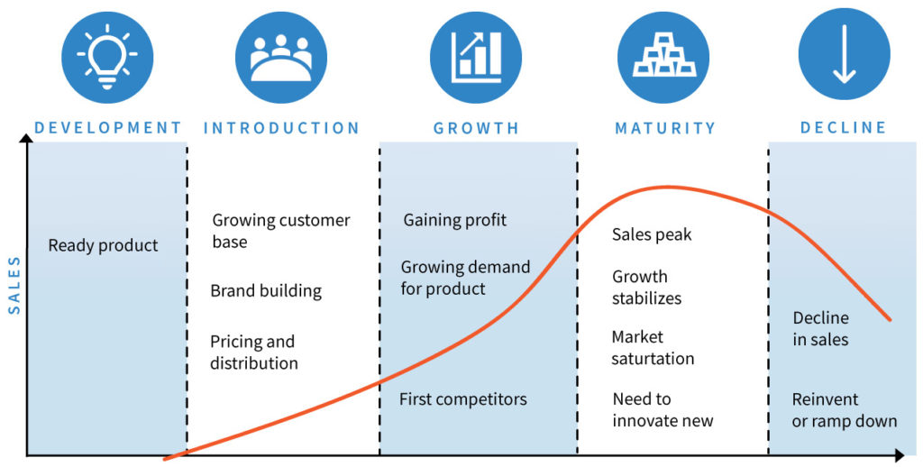

***Geographic Location***

The end-of-life disposal practices for a three-light table lamp can vary significantly based on the owner's geographical location, and this variation is influenced by several factors, including national regulations, cultural norms, and infrastructure. Let's compare the United States with another country, Canada, to illustrate these differences:

*United States:*

In the United States, the disposal of a three-light table lamp at its end-of-life is typically influenced by federal regulations as well as state-specific guidelines. Here are some key points:

* Recycling Programs: The U.S. has a patchwork of recycling programs that vary by state and locality. Many states have established e-waste recycling programs that include table lamps. Residents often have access to designated drop-off locations or collection events for electronics recycling.
* EPA Regulations: The U.S. Environmental Protection Agency (EPA) provides guidance on the disposal of electronic waste, including lamps. These regulations aim to reduce environmental impact and promote responsible disposal.
* Retailer Take-Back Programs: Some U.S. retailers offer take-back programs for electronics, allowing consumers to return old items, including table lamps, when purchasing new ones. These programs are often voluntary and may not be available at all stores.
* Private Recycling Companies: Private recycling companies specialize in handling electronic waste. They may accept table lamps and ensure proper disposal according to federal and state regulations.
* Donation: Donating functional table lamps to charities or thrift stores is a common practice in the U.S. This extends the lamp's life and reduces waste.
* Landfills: Disposing of table lamps in regular landfills is generally discouraged due to environmental concerns and potential hazards. However, it may still occur in some areas without specific e-waste regulations.

*Canada:*

In Canada, the disposal practices for a three-light table lamp can also vary by province and territory due to the country's federal system. Here are some general observations:

* Recycling Programs: Similar to the U.S., Canada has e-waste recycling programs in place, but they are managed at the provincial level. Provinces like Ontario and British Columbia, for example, have well-established programs that cover a wide range of electronic items, including table lamps.
* Federal Regulations: The Canadian federal government provides guidelines and regulations for electronic waste management. However, the implementation and specifics often fall under provincial jurisdiction.
* Retailer Take-Back Programs: Some Canadian retailers participate in take-back programs for electronic waste. Customers can return old electronics, including lamps, when purchasing new ones.
* Private Recycling Companies: Private recycling companies operate across Canada and handle electronic waste, including table lamps, in compliance with provincial regulations.
* Donation: Donating usable table lamps to charities or second-hand stores is a common practice in Canada, similar to the U.S.
* Landfills: Disposing of electronic waste, including lamps, in regular landfills is generally discouraged and often prohibited due to environmental concerns. Provincial regulations may differ on this matter.

In summary, while both the United States and Canada have established e-waste disposal practices and regulations, the specific details and implementation can vary by state/province and even by city or locality. The end-of-life options for a three-light table lamp in these countries are influenced by a combination of national and regional factors, making geographical location an important determinant of disposal practices.



***Strategies for Change***

Sustainable manufacturing of table lamps involves a comprehensive approach to reduce environmental impact, minimize resource consumption, and promote ethical and responsible practices throughout the lamp's lifecycle. we'll delve into various strategies and considerations for enhancing the sustainability of table lamp manufacturing.

*1.* *Design for Sustainability:*

The journey toward sustainable manufacturing begins with the design phase:

* Material Selection: Choose eco-friendly materials like recycled metals, sustainable wood, or bamboo for the lamp's body. Avoid hazardous or non-recyclable materials whenever possible.
* Modular Design: Create a modular design that allows for easy disassembly and replacement of components. This promotes repairability and extends the lamp's lifespan.
* Energy Efficiency: opt for energy-efficient lighting technologies, such as LED bulbs, which consume less energy and have a longer lifespan compared to traditional incandescent bulbs.

*2. Resource Efficiency*

Efficient use of resources is a cornerstone of sustainable manufacturing:

* Waste Reduction: Minimize material waste during production by optimizing cutting and shaping processes. Consider using reclaimed or salvaged materials when feasible.
* Water Management: Implement water-saving measures in manufacturing processes, such as recycling and reusing water, to reduce water consumption and minimize environmental impact.

*3. Energy Management*

Reducing energy consumption during manufacturing is vital for sustainability:

* Renewable Energy: Power manufacturing facilities with renewable energy sources like solar panels or wind turbines to reduce greenhouse gas emissions.
* Energy-Efficient Machinery: Invest in energy-efficient machinery and equipment to lower energy consumption during the manufacturing process.

*4. Local Sourcing and Production*

Supporting local economies and reducing transportation emissions are key aspects of sustainability:

* Local Sourcing: Source materials and components locally whenever possible to reduce transportation-related emissions and support local businesses.
* Local Production: Consider manufacturing the table lamps near the source of materials to further minimize transportation.

*5. Responsible Supply Chain Management*

Ensure ethical and sustainable practices throughout the supply chain:

* Supplier Audits: Regularly audit suppliers to ensure compliance with ethical and environmental standards. Seek suppliers with certifications like ISO 14001 (environmental management) and Fair Trade.
* Conflict-Free Materials: Avoid materials sourced from conflict zones, such as conflict minerals, to promote peace and ethical practices.

*6. Packaging and Transportation*

Consider the environmental impact of packaging and transportation:

* Eco-Friendly Packaging: Use eco-friendly packaging materials like recycled cardboard or biodegradable plastics. Minimize packaging to reduce waste.
* Efficient Transportation: Optimize transportation routes and modes to reduce emissions and energy consumption.

*7. Longevity and Durability*

Design the table lamp for durability and longevity:

* Quality Construction: Use high-quality components and craftsmanship to ensure the lamp lasts for a long time.
* Repairability: Make it easy for consumers to repair and maintain the lamp. Offer replacement parts and repair services.

*8. Lifecycle Assessment*

Conduct a comprehensive lifecycle assessment to identify and address environmental impacts at every stage:

* Raw Material Extraction: Assess the environmental impact of sourcing raw materials and explore sustainable alternatives.
* Manufacturing: Identify areas for improvement in energy consumption, waste generation, and emissions during production.

In summary, our sustainable table lamp is a testament to our unwavering dedication to environmental responsibility and ethical manufacturing. By integrating these strategies into every step of our production process, we have not only created a product that illuminates spaces but also lights the way toward a more sustainable future. It is a beacon of innovation, a symbol of our commitment to reducing our ecological footprint, and an embodiment of our pledge to leave a lasting positive impact on our planet.

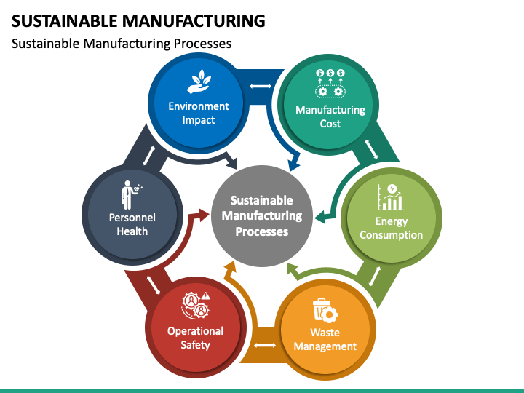

***Conclusion: Recommendations***

In conclusion, this report has provided a comprehensive overview of the table lamp, delving into its design, functionality, and market trends. We have explored the various components that make up a table lamp, from the base and pole to the shade and light source. Additionally, we've discussed the evolution of table lamp design over the years, with a focus on energy-efficient and smart lighting technologies. It is evident that the table lamp continues to be a versatile and indispensable lighting solution for homes and offices alike. As consumers increasingly prioritize energy efficiency and aesthetics, manufacturers are responding with innovative designs and sustainable materials. This report underscores the enduring appeal and adaptability of the table lamp in the ever-evolving world of lighting solutions.

Here are some of the Recommendations for Sustainable Table Lamps and Their Significance:

*1. Design for Disassembly and Recycling:*

*Why it matters:* This recommendation enables easier lamp disassembly and recycling at the end of its life. It reduces waste and encourages responsible disposal, contributing to a circular economy.

*2. Reduce Packaging Waste:*

*Why it matters:* Eco-friendly packaging minimizes waste and reduces the lamp's overall environmental impact, while efficient packaging reduces transportation emissions.

*3. Energy-Efficient Manufacturing:*

*Why it matters:* Reducing energy consumption during production lowers greenhouse gas emissions, minimizing the lamp's carbon footprint.

*4. Regulatory Compliance:*

*Why it matters:* Compliance with environmental regulations like RoHS and WEEE ensures the lamp is safe, free from hazardous materials, and properly disposed of at the end of its life.

*5. Consumer Education:*

*Why it matters:* Educating consumers about the lamp's sustainable features empowers responsible use and disposal, fostering eco-conscious behavior.

*6. Circular Economy Approach:*

*Why it matters:* Implementing take-back programs and refurbishment services reduces waste, promotes reuse, and contributes to a circular economy, where resources are conserved.

*7. Ethical and Fair Labor Practices:*

*Why it matters:* Ensuring fair wages, safe working conditions, and labor rights throughout manufacturing supports ethical treatment of workers and responsible production.

*8. Certification and Eco-Labeling:*

*Why it matters:* Certifications like Energy Star and eco-labels validate the lamp's eco-friendliness, providing consumers with confidence in their sustainable purchase.

In summary, these recommendations are essential for sustainable table lamps because they collectively reduce environmental impact, conserve resources, promote ethical practices, and encourage responsible consumption. They align with the growing demand for eco-friendly products, benefit both the environment and society, and enhance a company's reputation in an increasingly conscious market. Embracing these recommendations is not only a responsible choice but also a path to a brighter, more sustainable future.

***Bibliography***

* <https://www.oecd.org/innovation/green/toolkit/actionstepsforsustainablemanufacturing.htm>
* <https://www.walmart.com/ip/Mainstays-3-5-Watt-Dimmable-LED-Desk-Lamp-with-USB-Port-Black/956008627>
* <https://haltian.com/resource/new-product-development-cycle-infographic/>
* <https://www.springwise.com/innovation/architecture-design/3D-printed-table-lamp-uses-sustainable-materials/>
* [https://flos.com/en/us/blog/buying-guide-modern-table-lamps-us.html#](https://flos.com/en/us/blog/buying-guide-modern-table-lamps-us.html)
* <https://www.sustainably-chic.com/blog/sustainable-lamps-and-light-fixtures>
* <https://www.coohom.com/article/a-guide-to-stunning-color-combinations-for-sustainable-table-lamps>
* <https://www.ellementry.com/blog/the-importance-of-eco-friendly-table-lamps/>
* <https://www.lightology.com/index.php?module=how_to&sub=green_designers>